**Part 4: Please attach a supporting document for the following prompt.**

*You are designing the in-game interfaces for social features. One particular feature allows you to:*

*See a list of all your friends online in the front end (main menu)*o *Add or remove players as friends*o *Prioritize some friends as “favorites” who will receive preferential treatment in-*

*game and in the list of friends*

*Using a simple wireframe, describe how the “favorited” players are treated relative to other players in any of the following: scoreboards, leaderboards, game stat comparisons, or any other place of your choosing where a list of players appears in a modern, next-generation console game.*

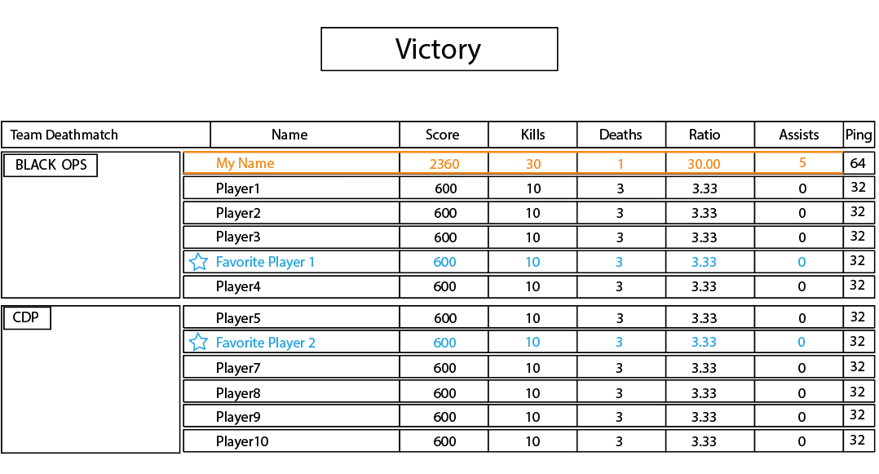

“Favorited” players are treated differently in two ways.

1. All the stats related to them, except for ping, are in a different font color (blue) than both the current player (orange) and other players (white).
2. There will be a star (having same color as the favorite player name) in front of the “favorited” player’s name, indicating that this player is “favorited”. The column remains empty for other non-favorite players and the current player.